November 2014 Volume 24 Issue 11

THE GOOD NEWSLETTER
of New Jerusalem Lutheran Church
27 Lyons Road, Fleetwood, PA 19522
E-mail: njelchurch@windstream.net
Website: NewJerusalemLutheranChurch.weebly.com
Office Phone: 610-682-6064
Church Office Hours: Monday thru Thursday 9:00 a.m.–12:00 noon
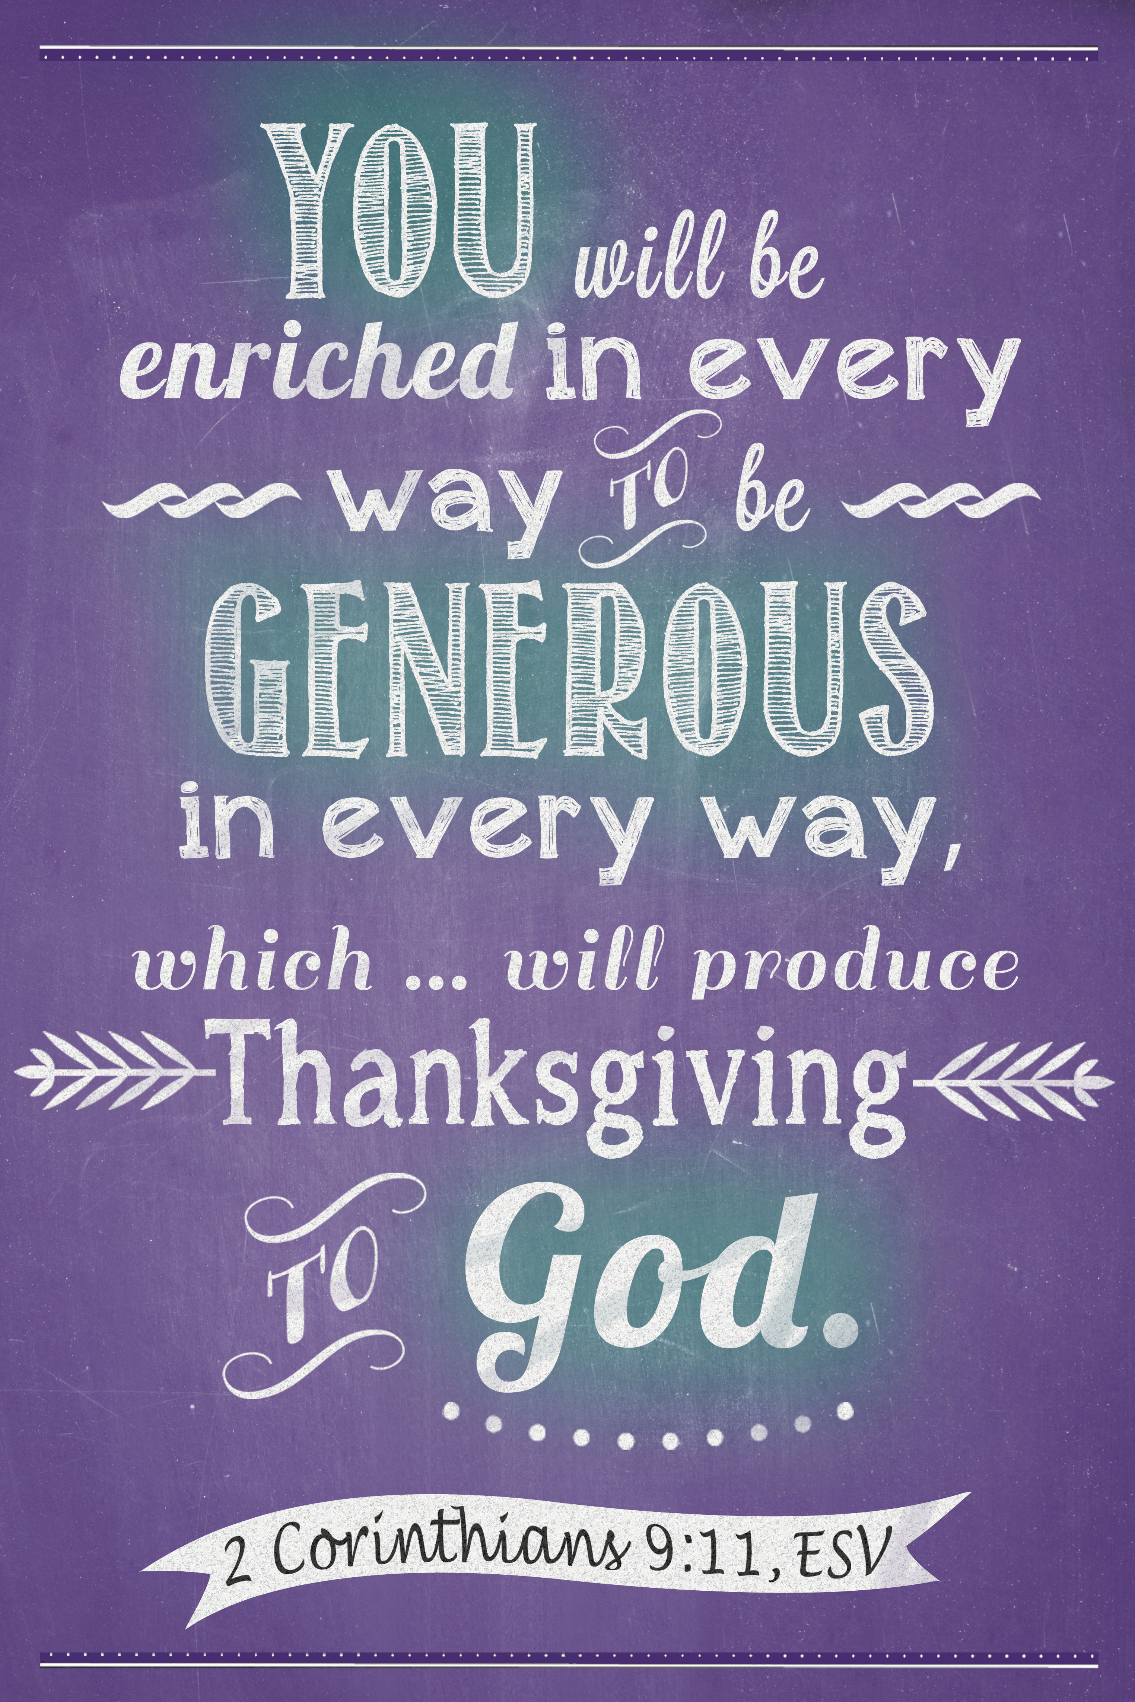

THE MISSION OF
NEW JERUSALEM LUTHERAN CHURCH:

We are a group of people who
gather together in friendship and love
to worship God, to spread God’s Word,
and to care for God’s people.



“The grass withers, the flower fades”

How true these words are for November! Leaves are falling from the trees. Mums have about given up their color. It is time to put the lawn mower away for the winter. Days are much shorter, often damp and cold and gray. We start this month’s worship thinking about those who have died.

As we wind down our church year, some find the lessons about Jesus’ second coming to be lugubrious. Now there’s an old word that sounds like what it means! Luh ‘goo bree us, means mournful. The word itself sounds so very heavy, burdensome. Many of us carry heavy burdens and there is a burdensome nature to some of the texts we will hear. Amos will tell us that the “day of the Lord” (the end times) will be a day of darkness, not light. Zephaniah will repeat that the day of the Lord will be one of judgment and wrath. Jesus will tell us that if we are not ready for his coming, we’ll be locked out and that it is not enough to maintain things as they are.

But wait! There are messages of hope! On All Saints’ Sunday we will hear Jesus’ comforting words, “Rejoice and be glad!” Rejoice and be glad no matter whether you are poor in spirit, mourning, hungry and thirsty for righteousness, or persecuted. And on the last Sunday, Christ the King Sunday, we will hear from Ezekiel that even though Israel had had really bad rulers, (they often called “shepherds,”) God would set over them a shepherd-messiah, who would feed and truly care for the people. We will also hear Jesus say, “Come, inherit the kingdom prepared for you.” In other words, God is and will be with us. God will act for us and there will be an end to all that is hurtful and wrong.

But what will we make of these messages, particularly the ones which urge us to be ready and act the way God wants us to? Jesus tells us to make good use of, invest, the talents (aka gifts) you have been given. Don’t worry about what you don’t have or how little you think you have been given. Invest what you do have. (Matthew 25:14-30).

So, what are the talents, the gifts, we here at New Jerusalem have been given? Some are the same as those with which the congregation was blessed from the very beginning: God’s good Spirit, word and sacraments, land and a building, and a community of believers willing to share their personal time and talents to build the community. Some of the gifts we currently have are different from those we had even a few years ago. How aware are we of what and how much we have been given?

As we prepare for our national day of thanksgiving, let us become more aware of and name our gifts, our resources as a congregation. Then, let us ask God to help us invest them wisely so that they may bring rich blessings to others today and tomorrow.

“The grass withers, the flower fades, but the word of the Lord endures.” (Isaiah 40:8) “O Give thanks unto the Lord, for God is good and God’s mercy endures forever!” (Psalm 118:1)

Pastor Ruth





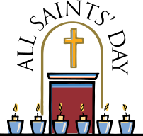
ALL SAINTS’ SUNDAY – On
Sunday, November 2, we will
remember all the church’s
saints who have passed to the Church Triumphant. As is our tradition, we will light one candle for each of the members of New Jerusalem that have died since the last All Saint’s Sunday. At this time: Gary R. Guinther, Cody J. Seaman, Mary E. Miller, and Phyllis A. Moyer.

On November 2, All Saints’ Sunday, we will celebrate that the love of God endures from the beginning of time beyond life as we know it. Please bring your personal or family Bible to church. Please also share in writing a favorite passage or Bible story, and be sure to include your name. Don’t know the exact location of a favorite verse? No problem. Just jot that down as best you remember it.

CHRIST THE KING SUNDAY will be held on November 23. Holy Communion will be celebrated.

SERVICE OF HEALING will also be held on Sunday, November 23. Members will be invited to come forward for the laying on of hands and anointing, with prayers for the well-being of body, mind, and spirit.
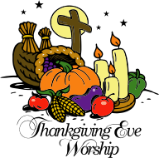
THANKSGIVING EVE
COMMUNITY SERVICE with Holy Communion will be held on Wednesday, November 26, at 7:00 p.m. This year Hope Lutheran Church, Bowers, will be hosting the worship service. We will be joining together with Christ Mertz, Dryville, to thank God for his bountiful gifts. Refreshments and a time of fellowship will take place after worship. Please join us!

DECEMBER NEWSLETTER DEADLINE is Sunday, November 23.
LIGHTING OF THE ALTAR CANDLES – There is a new sign-up sheet hanging on the bulletin board in the narthex. We need volunteers to light the candles on the altar at the beginning of each Sunday worship service. Please consider signing up if this is something you would be interested in doing. Thank you!

NOVEMBER SIGN-UP SHEETS – We are in need of Bulletin sponsors for November 2, 9, and 16; a Children’s Bulletin sponsor; volunteers to light the Altar Candles on November 9, 16, 23, and 30; a Communion Bread sponsor for November 23; a Communion Set-up volunteer for November 23; and Altar Guild volunteer(s) for November. Thank you to everyone that has signed up.

POINSETTIA FLOWER SALE – I know, I know, how can we be thinking about Christmas already, but we are. Enclosed in this newsletter is a Poinsettia Order Form. We will be decorating the sanctuary with red poinsettias for Christmas. If you are interested in ordering any poinsettias, just fill out the order form and return it with your payment to the church office by Sunday, December 14. The cost is $9.00 for a 6-inch pot.




DAYLIGHT SAVINGS TIME ENDS on Sunday, November 2. Members are reminded of the fall time change. Don’t forget to turn your clocks back one hour before bedtime on Saturday evening.


SHOO-FLY PIE BAKE SALE is scheduled for Tuesday, November 4 through Wednesday, November 5. Please call the church office at 610-682-6064 if you would like to order any pies. Pies are $5.00. NOTE: This will be the last bake until spring.
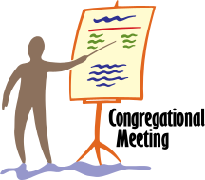
CONGREGATIONAL MEETING
will be held after the worship service on Sunday, November 9. The inclement weather date is scheduled for Sunday, November 16. The agenda for this meeting includes electing council members and approving the proposed 2015 budget. A copy of the proposed budget was included in a letter mailed to members of New Jerusalem. If you have misplaced your copy, extras will be available at the meeting. We need your attendance at this very important meeting. Thank you!

LOAVES AND FISHES – Free community meal will be held Tuesday, November18, from 5:30 p.m. to 7:30 p.m. at Trinity Lutheran Church, 121 S. Home Avenue, Topton. Everyone is welcome!

OFFICE CLOSED – The church office will be closed on Thursday, November 27, and Monday, December 1, in observance of the Thanksgiving holiday.

OLD PHOTOGRAPHS WANTED! Do you have any photographs (old or new) from New Jerusalem that you would like to share? We would like to use them for our 175th Anniversary Celebration. If you would like to share any of your photos, you can mail them to the church office. All photos will be returned. Thank you for your help!

CHECK OUT NEW JERUSALEM’S NEW WEBSITE – You can log on at newjerusalemlutheranchurch.weebly.com.

Let the church office know of any comments or suggestions you may have.

“Not what we say about our blessings,
but how we use them, is the true
measure of our thanksgiving.”
—W.T. Purkiser

Please Remember the Following
in Your Prayers:

Please pray for: (current list) Anna Angstadt, Dallas Angstadt, Cliff Barlet, Bertha Bennecoff, Jean Deysher, Karl Fenstermacher, Erma Gajewski, Erma Guinther, Paul Hertzog, Sheila Long, Gladys Luckenbill, Mary Merkel, Linda Moyer, Lloyd Moyer, Harvey Noll, Irene Noll, Mildred Reinert, Warren Reinhart, Joyce Rothermel, Betty Stoudt, Arlene Yob, George Christian, Shirley Diaz, Shelly Eller, the Ellis family, Marilyn Franzi, Myles Hansbury, Corinne Hersh, Lauren Kinney, Mike Krick, Patricia Noll, Lananh Rissmiller, Russell Roeder, Andrew S., Josh S., Theresa S., Jerry Schwambach, Tom Spraut, Jack Stoudt, Karen W., Veronica White, all our military personnel serving around the world, peace in the world, especially the Middle East and the Ukraine, and all those affected by the Ebola outbreak.


(long-term) Samuel Behm, Shirley Hertzog, Erma Noll, Ralph Harris, Mae Hertzog, Jack Krause, MM3 Elise Barlet, Major Jeromy Guinther, and the mission of our church.



Drena Kocher
Mifflin Center
500 Philadelphia Avenue
Reading, PA 19607

Myrtle Merkel
Topton Lutheran Home
1 South Home Avenue, Room C-172
Topton, PA 19562

Harvey and Irene Noll
204 Walnut Ridge Estates
Pottstown, PA 19464

New Jerusalem Lutheran Church
Statement of Accounts
September 30, 2014

Asset Accounts Balance
Memorial $ 25,635.40
Thrivent 5,934.66
Checking 14,546.22
Youth 965.04
Fidelity 167,716.91
Cash Reserve 24,144.23
Endowment CD 11,150.48

September 2014 — ‘Actual’ vs. ‘Required’ Income

Income
Income Required Actual
Used For: Per Month Income Delta
Operating
Expenses $9,787.08 $4,203.00 ($5,584.08)

Income Required per Month — Based on 2014 Budget Passed by Congregation



Many churches celebrate one Sunday a year as Christ the King Sunday. That day will be November 23 this year. A text in the New Testament speaks of Jesus the Christ as being “Lord of lords and King of kings.” Which one of the following New Testament books has that accolade? Mark your choice below.
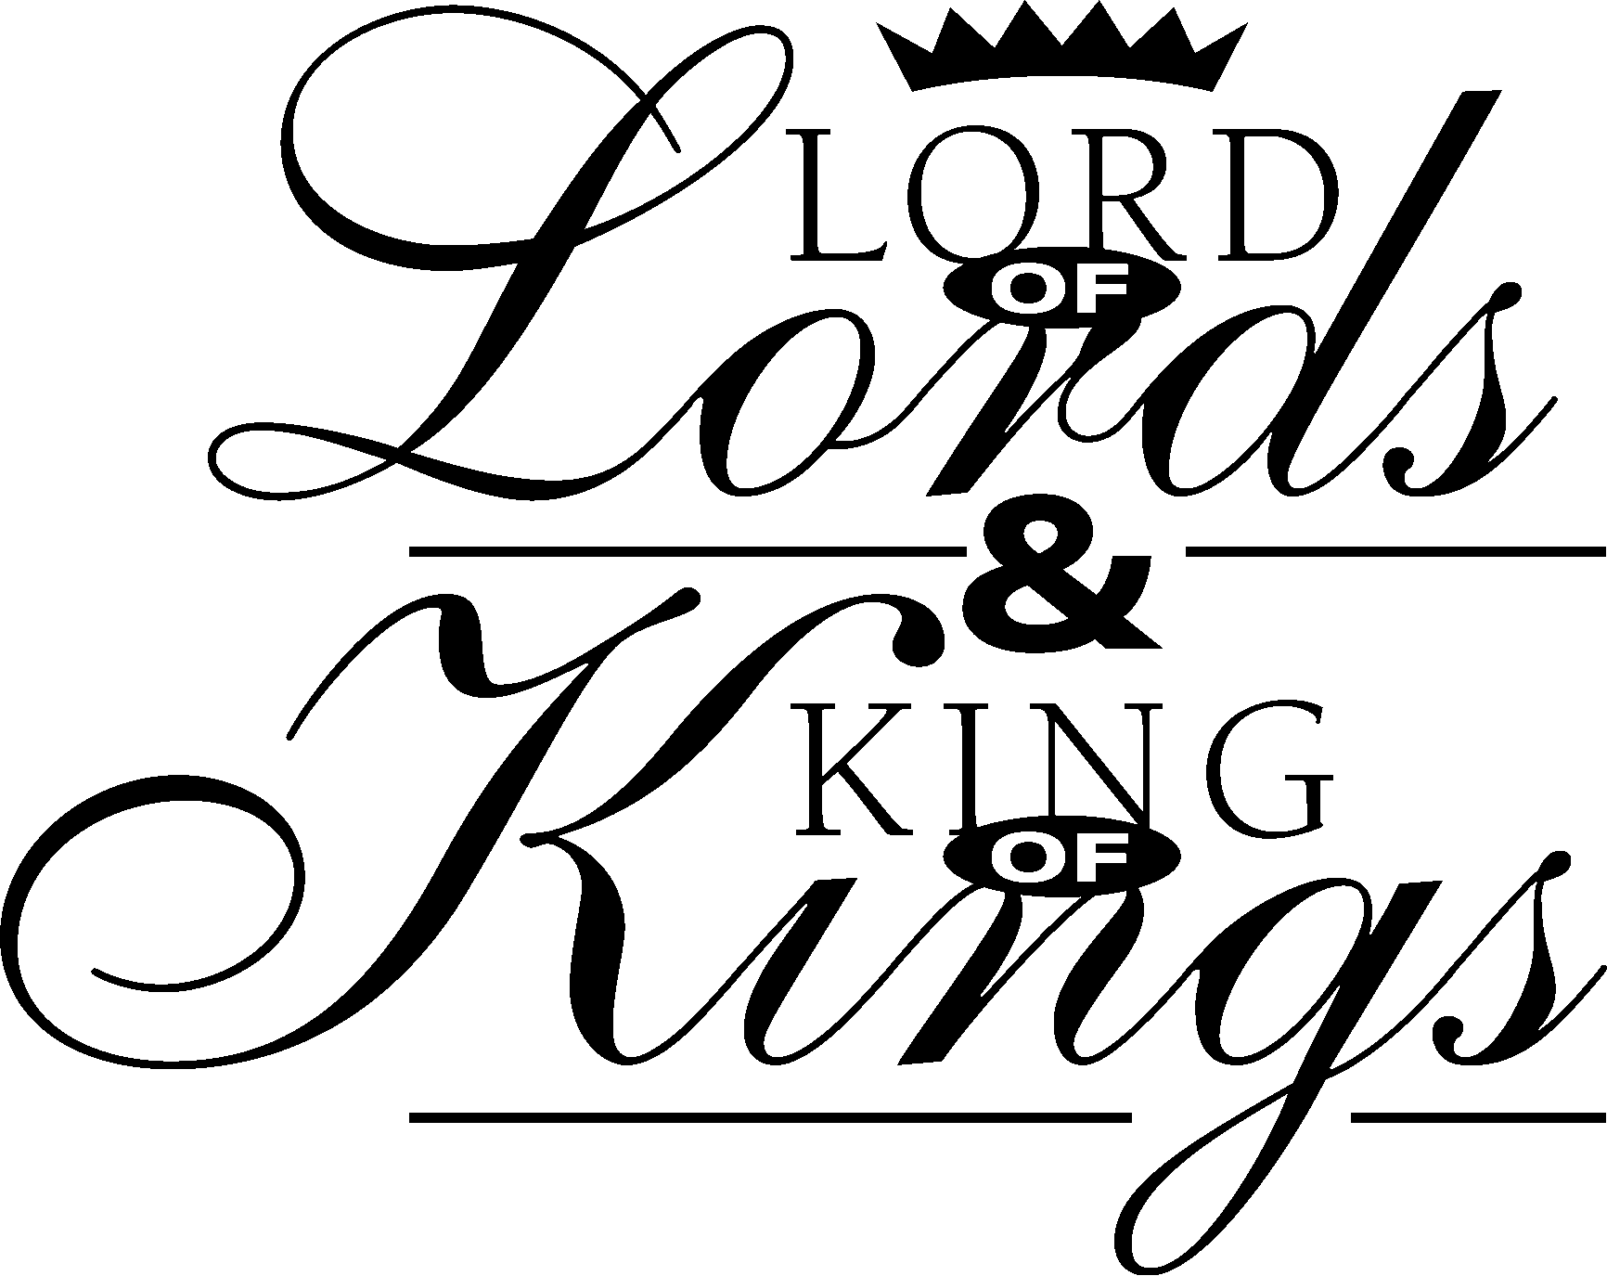
- ____Revelation
- ____Acts
- ____Colossians

Answer: A (Revelation 17:14)


Veterans Day has its roots in what was called Armistice Day, the day when a peace agreement was signed with Germany ending World War I. Armistice Day was established with a proclamation by President Woodrow Wilson which reads in part: “Armistice Day will be filled with solemn pride in heroism of those who died in the country’s service and with gratitude for the victory, both because of the thing from which it has freed us and because of the opportunity it has given America to show her sympathy with peace and justice in the councils of the nations.” On June 1, 1954, Armistice Day was renamed Veterans Day to honor all U.S. veterans.

On Veterans Day this year, let us remember and honor those men and women who gave of themselves, and let us continue to pray for our men and women currently serving in the military.

(Reprinted from The Newsletter Newsletter)

BRANDYWINE AREA CHURCHES FOOD PANTRY – Below is a list of current needs. The highlighted items are items they are currently low on. Canned fruit (any variety), cake mixes (any), canned meat (spam, tuna, turkey), cereal, coffee (regular and decaf), tea bags, mustard, Chef Boyardee products, Progresso soup, pudding, pancake mix, flour, pickles, fruit juice, vegetable juice, toothpaste, paper towels, sloppy joe mix, ketchup, cooking oil, sugar, salad dressing, jelly, rice cakes, spring water (gallons), deodorant, shampoo/
conditioner, and toothbrushes. Thank you for your continued support.



+ Christian Symbols +

Cornucopia


Cornucopia, a Greek word meaning “horn of plenty,” has origins in Greek mythology. But the cornucopia became a religious symbol and was even stamped on Jewish coins. Overflowing horns, now common as Thanksgiving centerpieces, came to symbolize abundance and blessings.

ALL SAINTS’ DAY
Saturday, November 1, 2014

In the first days and years of Christianity, all Christians were often called saints (see 1 Corinthians 1:2, nrsv). As time went on, certain Christians who lived holy and sanctified lives became special examples of truly living “above the crowd” in their dedication and service on God’s behalf. As other Christians recognized these very pious souls, the Roman Catholic Church began to cherish them as true saints, commendable as examples to be remembered and appreciated. It was and is still the Pope who, after a thorough examination of the life of the holy person under consideration, can officially designate the person as a saint.

Protestants, following the New Testament, may still consider all Christians as saints. Yet those very unique Christians who have exhibited great commitment to Christ in special ways are often hailed as being saintly, especially after death. Phillips Brooks, for example, an Episcopal priest in Boston, was honored for his godliness with a statue placed in front of Boston’s Trinity Church. The sculpture depicts Christ resting his hand upon Brooks.

On All Saints’ Day, all Christians should remember those like Brooks who have faithfully passed the torch of faith and service to Christ’s followers.
(Reprinted from The Newsletter Newsletter)


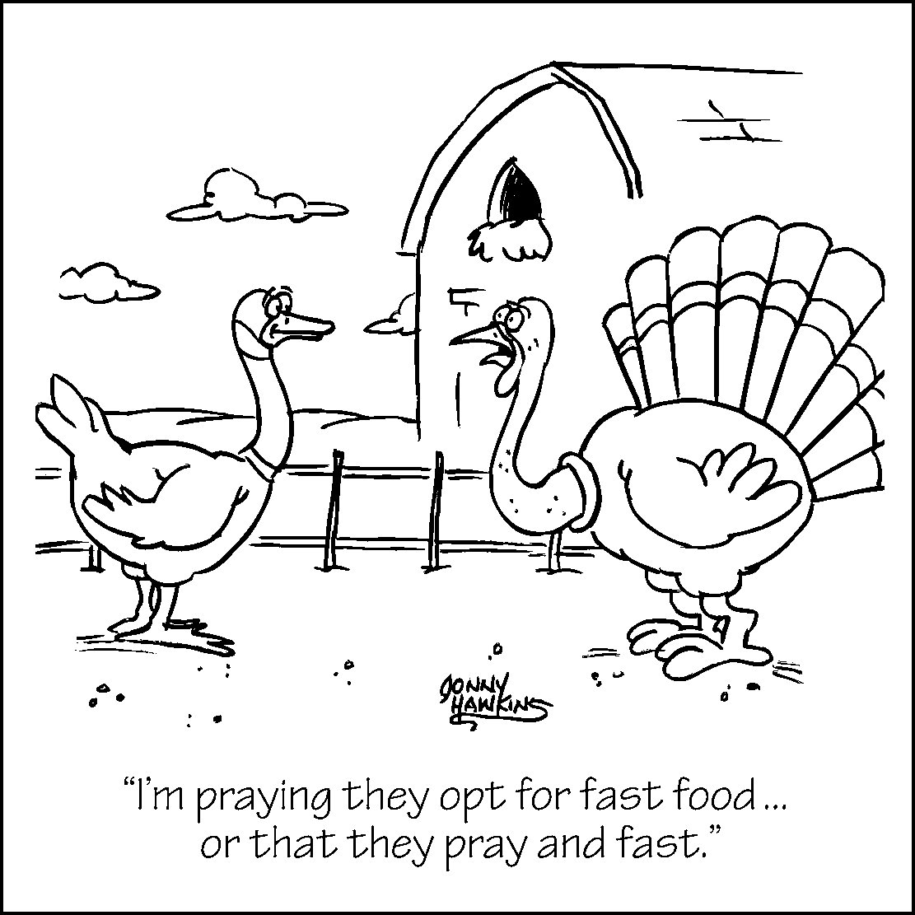

THANKSGIVING HOLIDAY FOOD BOXES
FOR FRIEND, INC. – There are two food lists on the table in the narthex. Donations of food items are needed to create Thanksgiving holiday meals. Your donations are due to church by Sunday, November 16. Please sign your name next to the item donated.

Join us for our


Saturday, November 1
3:00 p.m. to 7:00 p.m.

Rain Date: Sunday, November 2
3:00 p.m. to 7:00 p.m.

‘All Things Bright and Beautiful’

“All Things Bright and Beautiful” is a fitting hymn for Thanksgiving. Lyrics speak of opening flowers, singing birds, the sunset, morning brightening the sky, ripe fruits, purple-headed mountains and the running river. It ends:

“He gave us eyes to see them,
and lips that we might tell:
How great is God almighty,
who has made all things well.”

The hymn was written by Cecil Frances Alexander (1818-1895), an Irishwoman who was deeply devoted to the religious education of children. She wrote many hymns for her Sunday school class, most of which were published in Verses for Holy Seasons. She also ministered to the poor, the ill, the bereaved and especially children.

(Reprinted from The Newsletter Newsletter)



1 Janet Kepnach
1 Diana Moyer
5 Clifford Schlenker
5 Arlene Yob
6 Stacey Beshore
6 Justin Moyer
8 Lucas Beshore
10 Irene Noll
11 Cheryl Wiltrout
12 Lisa Landis
16 Barbara Fair
19 Linwood Merkel
24 Carolyn Dise
25 Horace Rothermel
27 Jeff Wengert
28 Baylee Cleaver
30 Mary Merkel

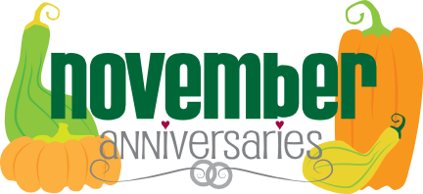

9 Dan and Kathy Bailey (12 years)
18 Joseph and Janet Kepnach (18 years)
25 Ty and Cindy Rissmiller (25 years)
28 Horace and Joyce Rothermel (55 years)

If your name or the name of someone
you know didn’t appear on this list,
we apologize and hope you will let
us know so we can make the
necessary corrections. Thank you.

Three-Month Worship Schedule

November

2 10:00 AM All Saints’ Sunday—Holy Communion (W)
* 9 10:00 AM Twenty-second Sunday after Pentecost (G)
16 10:00 AM Twenty-third Sunday after Pentecost (G)
*23 10:00 AM Christ the King Sunday—Holy Communion (W)
▪ Healing Service
26 7:00 PM Thanksgiving Eve Service—Holy Communion (W)
(Hope Lutheran, Bowers, hosts)
30 10:00 AM First Sunday of Advent (B)

December

* 7 10:00 AM Second Sunday of Advent—Holy Communion (B)
14 10:00 AM Third Sunday of Advent (B)
▪ Special Music Service
*21 10:00 AM Fourth Sunday of Advent (B)
*24 Christmas Eve (W)
5:00 PM Christmas Eve Family Service—Holy Communion
9:00 PM Christmas Eve Candlelight Service—Holy Communion
28 10:00 AM First Sunday of Christmas (W)

January

4 10:00 AM Second Sunday of Christmas—Holy Communion (W)
11 10:00 AM Baptism of Our Lord—Holy Communion (W)
18 10:00 AM Second Sunday after the Epiphany (G)
25 10:00 AM Third Sunday after the Epiphany (G)

FELLOWSHIP DATES:

( * ) Fellowship after worship



NOVEMBER 2014 ACTIVITIES


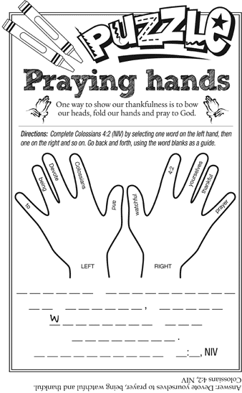

November Service Assistants & Sponsors

Date | Greeters | Readers | Altar Candles | Flowers | Bulletins
11/2 | Gladys Kline | Sara Jane Beshore | Sara Jane Beshore | Lisa Landis | (sponsor needed)
11/9 | Jeannette DeLong | Roy Merkel | (volunteer needed) | Sarah Bailey | (sponsor needed)
11/16 | Elaine Seip | Kathy Bailey | (volunteer needed) | Faye & Larry Dey | (sponsor needed)
11/23 | Lucille Jones | Ken Keck | (volunteer needed) | Don & Erma Gajewski | Don & Erma Gajewski
11/30 | Goldie Carl | Roy Merkel | (volunteer needed) | Richard & Goldie Carl | Gladys Kline

ALTAR GUILD: (volunteer(s) needed)
CHILDREN’S BULLETINS: (sponsor needed)
SANCTUARY CANDLE: The Rissmiller Family
COMMUNION BREAD: 11/2 – Sara Jane Beshore; 11/23 – Gladys Kline
COMMUNION SET-UP: 11/2 – Sara Jane Beshore; 11/23 – (volunteer needed)
COUNCIL PERSON: Betty Eshbach, 610-987-0358
COST: Flowers - $35.00; Bulletins - $7.00; Children’s Bulletins - $5.00; Sanctuary Candle - $15.00
(Please sign up on the sheets on the bulletin board where you are able to help. Thank you!)
NOVEMBER 2014
Sun | Mon | Tue | Wed | Thu | Fri | Sat
 |  | PLEASE NOTE: The church office will be closed on 11/27 in observance of the Thanksgiving holiday. |  |  |  | 3:00pm-7:00pm-Fall Campfire
2 | 3 | 4 | 5 | 6 | 7 | 8
All Saints’ Sunday/21st Sunday after Pentecost  ▪ Holy Communion  ▪ Campfire Rain Date   | Shoo-fly Pie Bake-► | 6:30pm-Bells  7:30pm-Choir  ---------------------------►  ELECTION DAY | 5:30pm-Worship & Music Committee Mtg.  ---------------►
9 | 10 | 11 | 12 | 13 | 14 | 15
22nd Sunday after Pentecost  ▪ Congregational Mtg.  after worship  ▪ Fellowship after Mtg. | 7:00pm-Finance Committee Meeting | 6:30pm-Bells  7:30pm-Choir  Bishop’s Conference   | Bishop’s Conference
16 | 17 | 18 | 19 | 20 | 21 | 22
23rd Sunday after Pentecost  ▪ Congregational  Meeting Inclement  Weather Date | 7:00pm-Council Meeting | 6:30pm-Bells  7:30pm-Choir | 11:30am-Fellowship Luncheon @ Janelle’s
23 | 24 | 25 | 26 | 27 | 28 | 29
Christ the King Sunday  ▪ Holy Communion  ▪ Healing Service  ▪ Fellowship  30  First Sunday of Advent |  | 6:30pm-Bells  7:30pm-Choir | 7:00pm-Thanksgiving Eve Service  ▪ Holy Communion  (Hope Lutheran hosts) |   OFFICE CLOSED

New Jerusalem Lutheran Church ■ 27 Lyons Road, Fleetwood, PA 19522-9724 ■ Phone: 610-682-6064 ■Email: njelchurch@windstream.net

